TECHNICAL REPORT ON STUDENT INDUSTRIAL WORK EXPERIENCE SCHEME (SIWES)

HELD AT
ARCHTECTURAL INTERNSHIP CENTER,
YOLA, ADAMAWA STATE

FROM: 6TH OCTOBER, 2024
TO: 29TH JANUARY, 2025

TITLE PAGE

BY
WASINYA WILLIAM
(SE/ARC/ND/23/009)

SUBMITTED TO THE DEPARTMENT OF ARCHITECTURAL TECHNOLOGY, FEDERAL POLYTECHNIC MUBI, IN PARTIAL FULFILLMENT OF THE REQUIREMENT FOR THE AWARD OF NATIONAL DIPLOMA (ND) IN ARCHITECTURAL TECHNOLOGY

APRIL, 2025

DECLARATION
This is to declare that I, WASINYA WILLIAM with registration number SE/ARC/ND/23/009 undertook my Sixteen weeks SIWES at ARCHITECTURAL INTERNSHIP CENTER, YOLA, ADAMAWAW STATE and have acquired all the experience compiled in this report in the course of my SIWES.

……………………………….. ……………………………
WASINYA WILLIAM Sign/Date

CERTIFICATION
This is to certify that this report was compiled by WASINYA WILLIAM (SE/ARC/ND/23/009) and meets the regulations governing the award of National Diploma (ND) in Architectural Technology of the Federal Polytechnic Mubi, and is approved by:

………………………………. …………………………
Name of Supervisor Date
Departmental Supervisor

………………………………. …………………………
Arc. Daniel Barka Date
Departmental SIWES Coordinator

…………………………………. …………………………
Arc. Usman Mohammed Date
Head of Department

DEDICATION
I dedicate this technical report to my parents, my sisters and colleagues and to all those that supported me throughout me industrial training.

ACKNOWLEDGEMENTS
First of all, my sincere appreciation goes to Almighty God and salutation to my Lord Jesus Christ.
I wish to thank all staff of Architectural Technology department in Federal Polytechnic, Mubi.
My appreciation goes to my beloved parent for the motivation, prayers and financial support towards my SIWES exercise.
My special thanks go to my beloved brothers and sisters for all their care and support throughout my industrial training.
I want to also thank my colleagues and others; I really appreciate your efforts.

TABLE OF CONTENTS
TITLE PAGE i
DECLARATION ii
CERTIFICATION iii
DEDICATION iv
ACKNOWLEDGEMENTS v
TABLE OF CONTENTS vi
ABSTRACT viii
CHAPTER ONE 1
INTRODUCTION 1
1.1 Aim and objective of SIWES 1
1.2 Brief history of SIWES and ITF in Nigeria 2
1.3 Significance of SIWES to students 2
CHAPTER TWO 3
ARCHITECTURAL INTERNSHIP CENTER 3
2.1 Brief history of the Organization 3
2.2 Company Organogram 3
CHAPTER THREE 4
DESCRIPTION OF WORK EXPERIENCE 4
3.1 Setting out 4
3.3 Block work 6
3.4 Upper floor construction 8
3.5 Lintel construction 9
3.6 Column base construction and basket setting 11
3.7 Wire mesh construction 13
3.8 DPC and DPM construction 15
CHAPTER FOUR 17
SUMMARY, RECOMMENDATION AND CONCLUSION 17
4.1 Challenges encountered during siwes program 17
4.2 Summary 17
4.3 Conclusion 18
4.4 Recommendations 18
REFERENCES 19

ABSTRACT
The report summarises the result of work done during my SIWES experience, the technical report consists of four chapters, which comprises of introduction, history and criteria’s of SIWES in chapter one followed by their aims and objectives, historical background, organizational structure of the organization in chapter two, while chapter three consist of the work actually carried out during the SIWES programme and lastly chapter four consist of the summary, conclusions and recommendation.

CHAPTER ONE

INTRODUCTION
The acronym (SIWES) meaning “Student Industrial Work Experience Scheme” is a skill training designed to expose and prepare student in institution of higher for industrial working situation they may likely meet after graduation. The scheme is meant to train student on the method of work and the experience needed in handling the equipment and machines may not to be available in their institution. The scheme is financed by the Federal Government and operators through Industrial Training Fund (ITF), Ogwo, (2001) and operates with National University Commission (NUC), National Board of Technical Education (NABTEC), and National Commission for College of Education (NCCE) and industries. However, SIWES also expose the student to many practical works which the institution did not treat in details without plastering what the institution taught theoretically into practical. A point from academic obtained. SIWES assist the student to understand the nature of his/her work in future.

1.1 Aim and Objectives of SIWES
ITF initiates SIWES with the sole aim of: Exposing student with the practical experience related to the theoretical knowledge acquired in school. Bridging the gap between theoretical learning and practical work situation.
- To make industries/organization to have confidence in the abilities and capacities of the graduates. SIWES helps the industries to evaluate the prospective employees and give feedback to the institution.
- It helps the student to gain work and also have experience and confidence as a result if successful completion of a given job assigned to them.
- To enlist and strengthen the employers’ involvement in the institution activities and in the entire educational process of preparing the student for meaningful and productive employment into industries.
- It provides an avenue for student in the Nigerian University and Polytechnics to acquire industrial skill and experience in their course of study.
- Development for greater understanding in other people and proffers skills in human relations.

1.2 Brief history of SIWES and ITF in Nigeria
It was said by Dr. Azikiwe Nnamdi, the one president of Nigeria that the practice of work but they all have the same goal that they all want to achieve in countries like china. They established within the premises of institution to provide real life situation, lack of practical skill of locally trained engineers and technologies. the chine way and condition of SIWES is that all institution must give student real life working experience in industrial works. Lecturers are involved in the industrial activities rendering constant services. So, all these countries have their own way of conducting the scheme but all lye on the same goal. And in Nigeria, the history of SIWES can be traced by the history of IITF which is the backbone of SIWES. ITF was established in 1974 under degree of 47 of 1971. It was a body established by the Federal Government of Nigeria and was given responsibility of training indigenous Nigerians. The establishment of the body became necessary due to high demand of Nigeria to take up the vacant positions created in various sector of the economy after the colonial masters have departed. Therefore, the Federal Government discovered that it is easier to train students that are skilled in school to be trained and meet up with gaps in the Nigerian economy and a scheme was established to care for such training and it was named Student Industrial Work Experience Scheme (SIWES).

1.3 Significance of SIWES to students
Principles taught in the classroom are vein forced given concrete applications on the industrial assignment and students is able to see the relevance of their students which increase their motivation. It helps in given students the knowledge on the types of work to do after his/her graduation. SIWES given students opportunity for a change of environment as they move their institution to the place of attachment which changes the routine types of environment to a word of work. It helps in connecting the institution and the industrial their relationship the introduction of SIWES.

CHAPTER TWO

ARCHITECTURAL INTERNSHIP CENTER

2.1 BRIEF HISTORY OF THE ORGANIZATION
The Architectural Internship Center, Yola in Adamawa State was founded on the vision of nurturing future architects and building professionals through practical, hands-on experience and mentorship. Established in response to the increasing demand for qualified and skilled personnel in the architecture and construction sector, the center was inspired by the commitment of its founder, Ibrahim Musa, a civil engineer and advocate for sustainable development.
Since its inception in 2015, the center has grown into a reputable institution dedicated to excellence in both architectural training and professional project delivery. With a core mission to empower aspiring architects and engineers, the center combines academic knowledge with real-world application, preparing interns to meet modern design and construction challenges.
The Architectural Internship Center offers a comprehensive range of services, including: Architectural Design, Civil Engineering Services, Project Management, Construction and Renovation, and Consultancy:

2.2 COMPANY ORGANOGRAM
CHAIRMAN
DIRECTOR
MESSENGER
SUPERVISOR
STUDENTS

Figure 2.1: Organogram
Source: Author’s work, 2025

CHAPTER THREE

DESCRIPTION OF WORK EXPERIENCE

3.1 SETTING OUT
The Square Method was used to accurately set out rectangular or square buildings by ensuring all corners formed perfect right angles. It was based on the 3:4:5 rule from Pythagoras’ Theorem. The process involved measuring and pegging out straight lines, adjusting angles to form right corners, and confirming accuracy by checking diagonals. This method helped prevent construction errors and ensured the building's structural integrity. As noted by an engineer, accurate calculations during setting out were crucial for the building’s durability
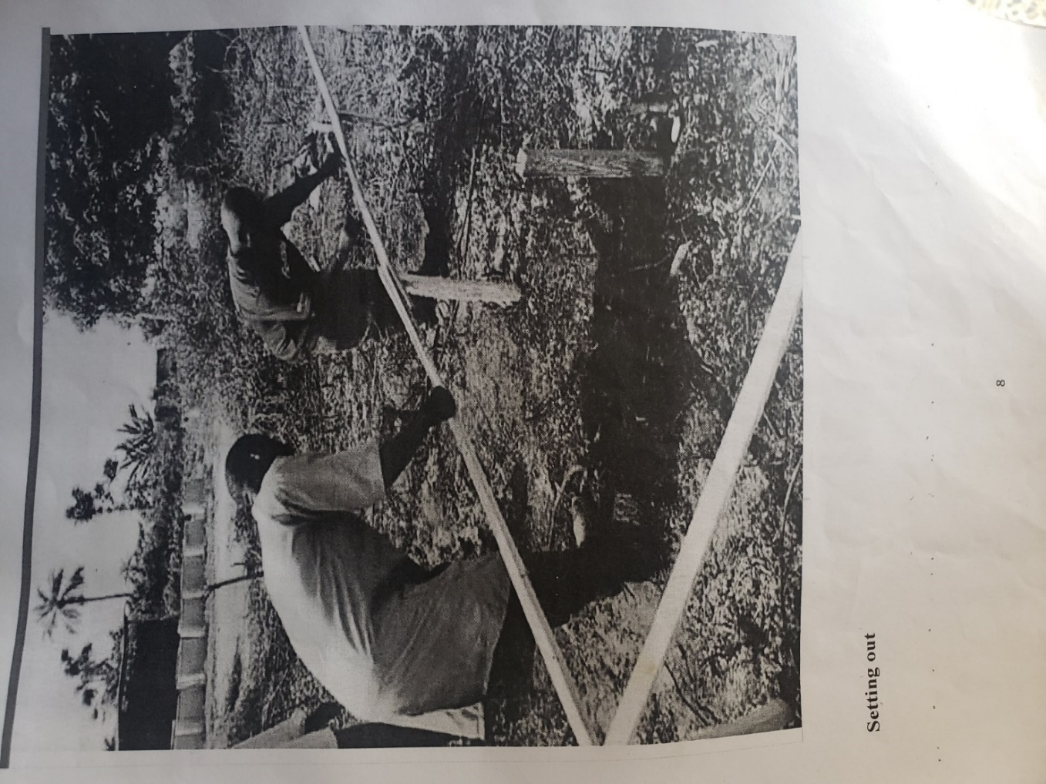
Plate 3.1: Setting out using profile board
Source: Author’s work, 2025

3.2 EXCAVATION OF FOUNDATION
Excavation can be defined as the process of digging a soil surface or trench for foundation lay into trench. It is also the process of removing top soil for foundation trenches. Excavation work is an important part of building operation that commences immediately after setting out the width of excavation for foundation trenches is marked out on the profile and then transferred to the ground. Excavation must be carried out carefully to ensure safety of workers.
Excavation can be done using two methods mechanical and manual. In small construction we normally use manual method while in large construction we use mechanical e.g. like road construction. Excavation work were carried out manually where unskilled labourer where involved with digger, shovels, head pan and wheel barrow. The following factors must be considered when carrying out any excavation work.
- Nature of the soil
- The width and depth of foundation
- Climatic condition at the time of excavation
- The water table of the soil
- The period excavation work is expected to be left open.
- The effect of excavation on existing adjacent structure.
As the engineer and the former goes to set basket, I was keeping an eye on how the beams were set. When digging the basket some places were 1.2 while some other places were 1.4 by 1.4 because of the type of soil on the site. When putting the basket in a poor soil, cement and sharp sand is mixed out before putting the basket to avoid rusting.

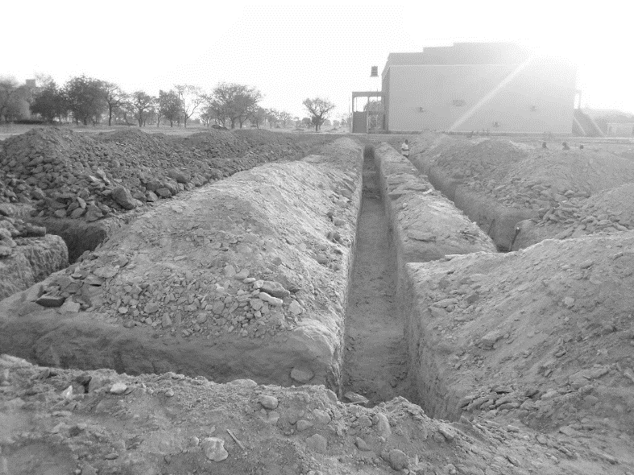
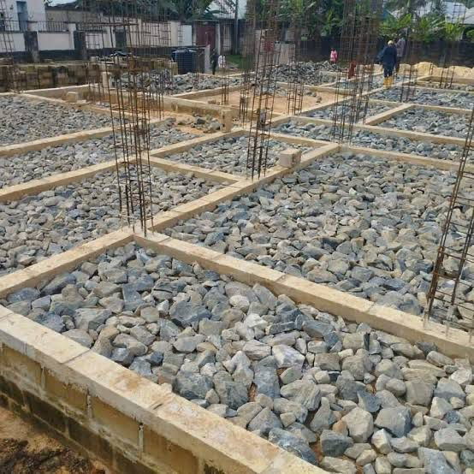

(a) (b)
Plate 3.2: (a) Hardcore laying and (b) Excavation of Foundation trench
Source: Author’s work, 2025

3.3 BLOCK WORK
Blocks were molded in a number of sizes, various compositions, strengths, and shapes such as 9 inches and 6 inches. The 9-inch blocks were used for external walls, while the 6-inch ones were for internal walls. After the foundation work was finished, the blockwork was built to cover the spaces as well. All the blockwork did not carry any load; they were erected to cover spaces and also act as partition walls.
Procedure
- Before starting the block laying process, the site was prepared by clearing debris and ensuring a level foundation.
- The layout of the walls or structure was marked using chalk lines or strings to guide the placement of the blocks.
- Blocks or bricks were selected based on the desired strength, size, and aesthetic requirements of the project.
- Mortar was mixed according to the specifications, typically using a combination of cement, sand, and water.
- A layer of mortar was spread evenly along the foundation where the first course of blocks would be placed.
- A level was used to check the horizontal and vertical alignment of the blocks.
- Once the first course was laid, additional courses of blocks were added on top, following the same process.
- Each block was buttered with mortar on its ends before being placed to ensure a strong bond between the blocks.
- Blocks may have needed to be cut to fit around corners, openings for doors or windows, or to maintain the desired pattern.
- Excess mortar was scraped off the joints using a trowel, and any gaps or voids were filled to create a smooth, uniform surface.
- Once the block laying was complete, the work area was cleaned up, and any excess materials or debris were removed from the site.
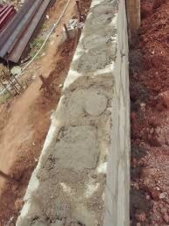
Plate 3.3: Block work, showing concrete
Source: Author’s work, 2025

3.4 UPPER FLOOR CONSTRUCTION
After completing the ground floor blockwork and slab, we moved on to the construction of the upper floor, which marked a significant stage in the building’s structural development. This phase involved several activities, including formwork installation, reinforcement fixing, electrical conduit placement, concrete casting, and curing.
We began by erecting formwork and scaffolding to support the upper slab and beams. The carpenters installed the formwork using strong planks and props, ensuring it was well-aligned and firmly braced to carry the load of the wet concrete. Once the formwork was in place, the steel fixers moved in to tie and position the reinforcement bars according to the structural drawing. During this stage, electrical conduit pipes were laid within the slab to allow for future wiring. These were placed in designated positions and tied securely to the reinforcement to prevent movement during casting. After a thorough inspection by the site engineer, we proceeded to pour concrete using a mixture of cement, sand, granite, and water in the appropriate ratio.
The concrete was poured in sections and vibrated properly using a mechanical vibrator to eliminate air pockets and ensure solid compaction. We worked quickly and efficiently to ensure that the concrete was poured continuously to avoid cold joints. Once casting was completed, the surface was leveled and smoothened using a trowel. After the concrete set, we began the curing process by keeping the surface moist for a minimum of 7 days to ensure proper strength development. The formwork was left in place until the concrete achieved sufficient strength to support its own weight and any additional load.

3.5 LINTEL CONSTRUCTION
After completing the blockwork up to the required height for doors and windows, we proceeded with the construction of lintels—a critical phase in providing structural support above all openings. The process began with the marking and measurement of all door and window openings to determine the exact length of each lintel. Once the dimensions were confirmed, the carpenters constructed the formwork (shuttering) for the lintels using strong timber, ensuring it was firmly braced and properly aligned.
Next, we tied the reinforcement bars according to the structural drawings. These bars were essential for strengthening the lintel and distributing the load above the openings. Spacers were used to maintain cover between the reinforcement and the formwork, which helps protect the steel from corrosion. Once the reinforcement was fixed and inspected by the engineer, we proceeded to pour concrete into the lintel formwork. The concrete mix was properly proportioned and vibrated to remove air pockets and ensure proper bonding and compaction. The top of the lintel was leveled and finished neatly using a trowel. After pouring, the lintels were left to cure and gain strength, and we kept the surface moist regularly to aid the curing process. The formwork was not removed until the concrete had fully set and reached the required strength, usually after 7 to 14 days. This stage was particularly important as the lintels help in transferring the loads from above openings to the supporting walls on both sides. Being part of this process helped me understand the importance of accuracy, proper formwork, and reinforcement placement in lintel construction.
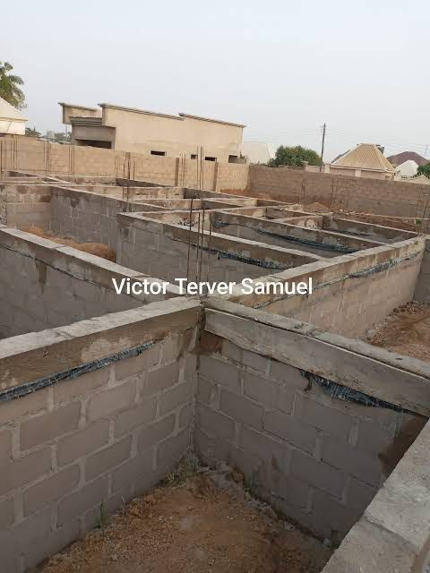
Plate 3.5: G. Beam Construction
Source: Author’s work, 2025

3.6 COLUMN BASE CONSTRUCTION AND BASKET SETTING
During the early stages of the building project, I was actively involved in the construction of column bases and the setting of reinforcement baskets, which formed the foundation for the vertical load-bearing elements of the structure. After the completion of the excavation work, the dimensions and depths of the column base pits were carefully measured and adjusted according to the structural drawings. The size of each pit varied slightly based on the nature of the soil, with softer areas requiring wider and deeper bases to ensure stability.
Once the pits were properly prepared, we proceeded to place and tie the reinforcement baskets. These baskets had been pre-fabricated by steel fixers using high-tensile steel bars and binding wire. I observed closely as each basket was carefully lowered into its designated pit, making sure that it was centered, vertically aligned, and adequately supported with spacers to provide enough concrete cover. In areas with weak or loose soil, we applied a dry mix of sharp sand and cement at the base before placing the basket to improve strength and reduce the risk of steel corrosion. Once the baskets were positioned correctly, the engineer supervised and approved the setup before concrete was poured. We then poured concrete into the column bases, ensuring it was well-compacted using a mechanical vibrator. The concrete was leveled and allowed to cure properly over the following days. Adequate moisture was maintained to support the curing process and achieve the required strength.
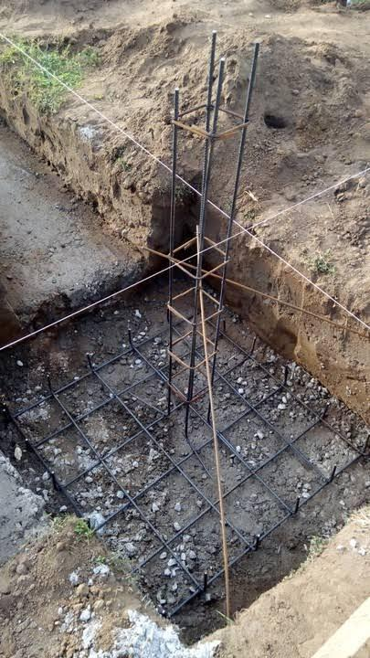
Plate 3.6: Column base setting
Source: Author’s work, 2025

3.7 WIRE MESH CONSTRUCTION
After completing the blockwork up to DPC level and filling the foundation with sand, we proceeded with the construction of the wire mesh, which was an essential step before casting the ground floor slab. The wire mesh helped to reinforce the slab, providing tensile strength and preventing cracks due to shrinkage or ground movement. The process began with the cleaning and leveling of the compacted sand filling to create a smooth and even surface for the mesh. Once the surface was ready, we began laying the BRC (British Reinforcement Concrete) wire mesh over the entire slab area as specified in the building design. We ensured that the mesh was properly overlapped, usually by about 150mm, and secured together using binding wire to maintain its position during concrete pouring. In areas where the mesh sheets had to be cut to fit around columns or tight corners, we carefully reshaped and rejoined them to maintain continuous reinforcement. Spacer blocks (concrete cover blocks) were placed underneath the mesh to raise it slightly above the ground level. This helped to ensure that the mesh was fully embedded in the concrete once it was poured, which is critical for durability and performance. Before pouring the concrete, the mesh layout was inspected and approved by the site engineer to ensure it complied with structural requirements. Being part of this process helped me understand how reinforcement works in concrete structures and the importance of accuracy and proper placement. The successful installation of the wire mesh marked the final stage before slab casting and played a significant role in strengthening the ground floor structure.
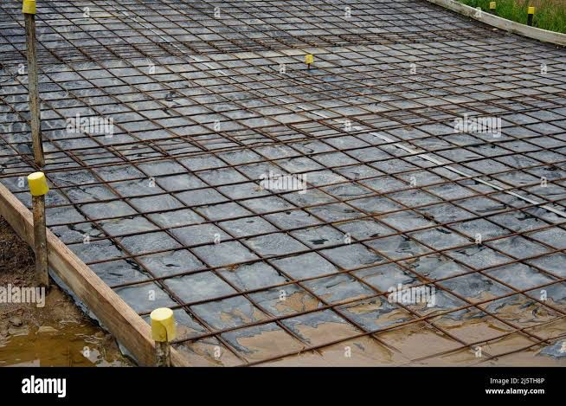
Plate 3.7: Wire Mesh
Source: Author’s work, 2025

3.8 DPC AND DPM CONSTRUCTION
Following the completion of foundation filling and compaction, I was involved in the installation of the Damp Proof Course (DPC) and Damp-Proof Membrane (DPM) to prevent moisture from rising into the building structure.
The DPC, which is typically a layer of waterproof material (such as thick plastic sheeting or bituminous felt), was laid horizontally on top of the blockwork at the base of the walls. This layer served as a barrier to stop ground moisture from seeping upward into the walls, which could otherwise lead to dampness and long-term damage. We made sure that the surface was clean and level before placing the DPC to ensure full coverage and effectiveness.
Right after laying the DPC, we also applied the Damp Proof Membrane (DPM) over the compacted sand and hardcore surface of the floor area. The DPM, which is a durable polythene sheet, was carefully spread out across the foundation floor and extended slightly up the sides to overlap with the DPC. This was done to create a continuous moisture barrier. We ensured there were no punctures or tears, and where necessary, joints were overlapped and sealed with waterproof tape.
The engineer on site emphasized the importance of both DPC and DPM in preventing moisture ingress, which could lead to mold, deterioration of materials, and an unhealthy living environment. Being part of this process gave me a better understanding of how critical these protective layers are in maintaining the integrity and lifespan of a building.
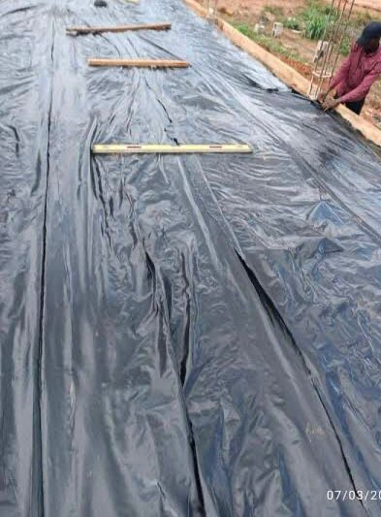
Plate 3.8: DPM and DPC
Source: Author’s work, 2025

CHAPTER FOUR

SUMMARY, RECOMMENDATION AND CONCLUSION

4.1 CHALLENGES ENCOUNTERED DURING SIWES PROGRAM
- The time frame set for the program is too short as some of the aspects of the program where not completed.
- Lack of Financial support from the company to aid transportation to and from training.
- Attentions are not given to the IT students by the workers it is learn if you want to learn or ask if you want to know.

4.2 SUMMARY
One would state that the discipline is the training of the mind and body towards effective performance. The Students Industrial Work Experience Scheme (SIWES) is more or less achieving this fit. As it further builds on the theoretical classrooms leaving a practical approach of the industry and commerce to supply of finished goods and services. This program has enabled the participating students to be practically involved in the day-by-day activities of the industries and commerce.
Emphasis in the observation of industrial safety rules and regulations, time critical operation and proper man-hand management, quality cortices, etc. are daily activity objective. All those aimed at the production of marketable goods and services in the world of work.
However, to consolidate on the gains of this Industrial Training Fund (ITF) higher institution coordinator on SIWES program should be allowed making some suggestion and recommendation.

4.3 CONCLUSION
SIWES programme is very vital student especially undergraduates, because I come to see the SIWES programme provide an application of the theoretical knowledge learned by student in school to practical or real work situation. Also, it is a medium where student from different higher institutions and department come together sharing idea there, by promoting an avenue for learning and them work.

4.4 RECOMMENDATIONS
Having being exposed to a bit of what entail working in an individual related to my course of study under SIWES programme I wish to make this recommendation
- Higher instruction of learning especially either institution and universities should establish link with comprise and establishment so as to provide space for student on industrial attachment, with the option of gaining employment in future, by doing so, it will go a long way in alleviating suffering and difficulties encountered by student in securing place for individual attachment.
- Student should put money as the primary aim of going SIWES programme, there is more to learn than Bain allowance.

REFERENCES
Chudley, R. (2005). Construction technology volume 2. Pearson Prentice Hall, New York.
Edward, B. (2003). The Effect of SIWES on a student, Federal Ministry of Works, Lagos. Nigeria.
Francis, K. (2012). Building Construction Illustration. (Fourth Edition). Wiley Publisher. ISBN-10: ‎ 9788126535637.

